Multimedia Web Design Homework
HTML EXERCISES (week 4)
Multimedia, Accessibility, Best Practices & Finalizing Your Portfolio

Eda Selmani – Computer Engineering

Exercise 1: Add a media section to your portfolio
Add a new <section id='media'> to your portfolio. Inside it: (1) Add an <h2> heading: 'Media & Work'. (2) Find a free, downloadable sample video online (or use any .mp4 you have), add it with the <video> tag with controls and a poster image. (3) Alternatively, if you have no video file: embed a YouTube video using an <iframe> — search 'YouTube embed code' and paste it in (more on iframes below!). (4) Add the new section to your nav bar. Save and test that your media appears correctly.
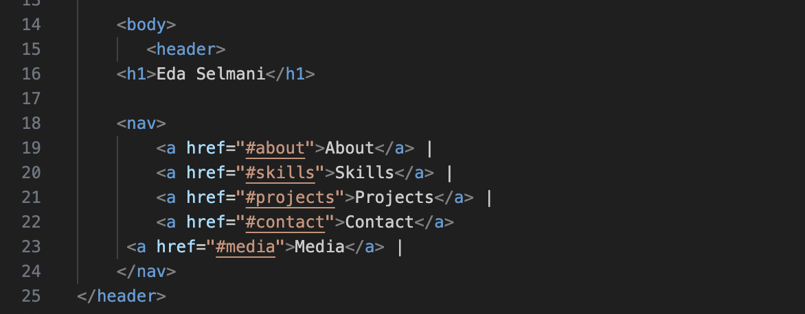
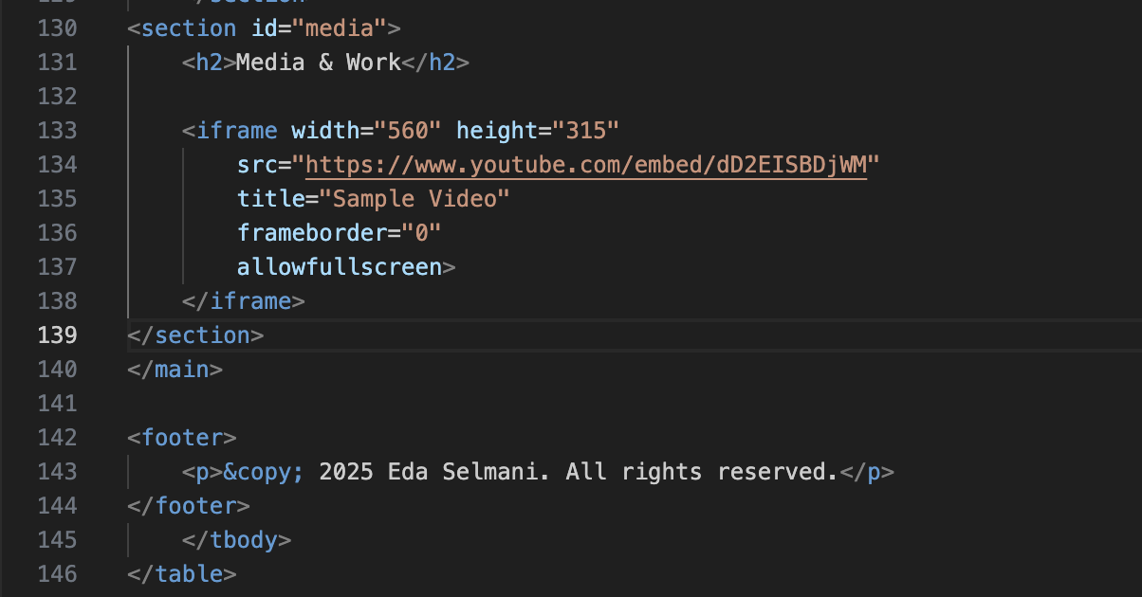

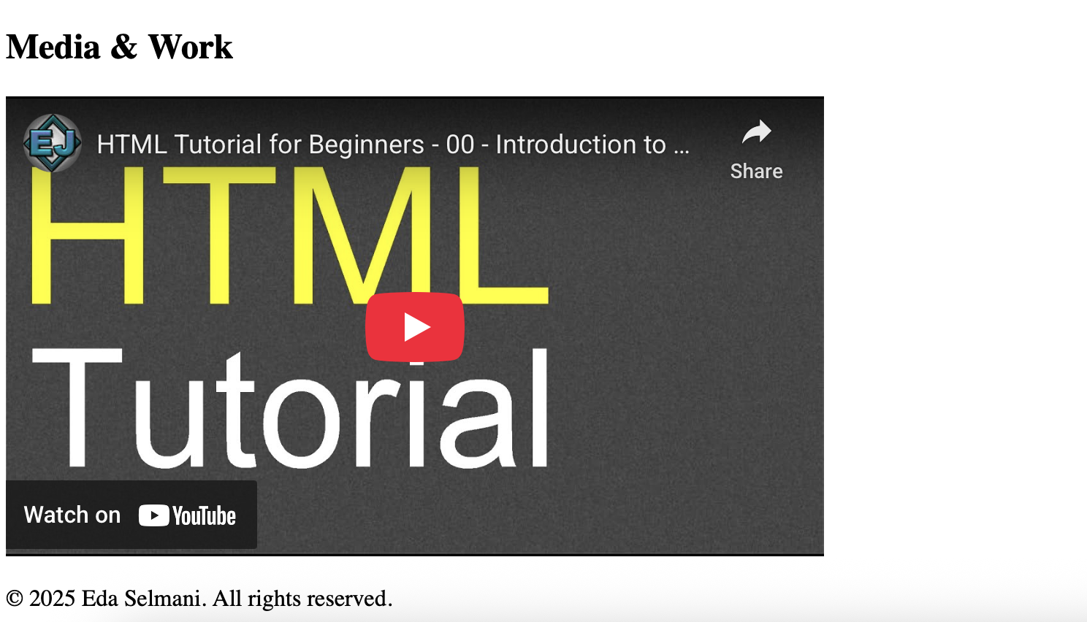

Exercise 2: Embed a youtube video and google map
Find an HTML tutorial video on YouTube. Copy its embed code (Share → Embed). Paste it into your Media section. (2) Go to Google Maps, search for Skopje (or your city). Click Share → Embed a map. Copy the iframe code and paste it into your Contact section below the form, inside a <div>. Add a small paragraph above it that says 'Find me here:'. (3) For both iframes, make sure they have a descriptive title attribute.
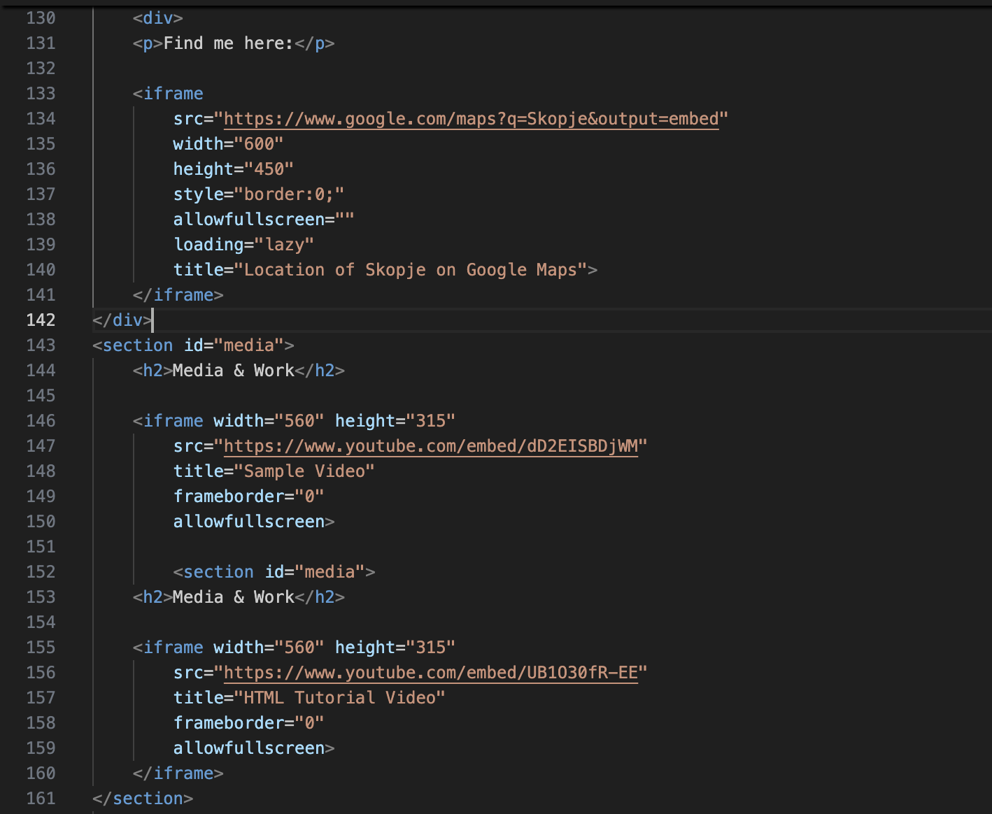
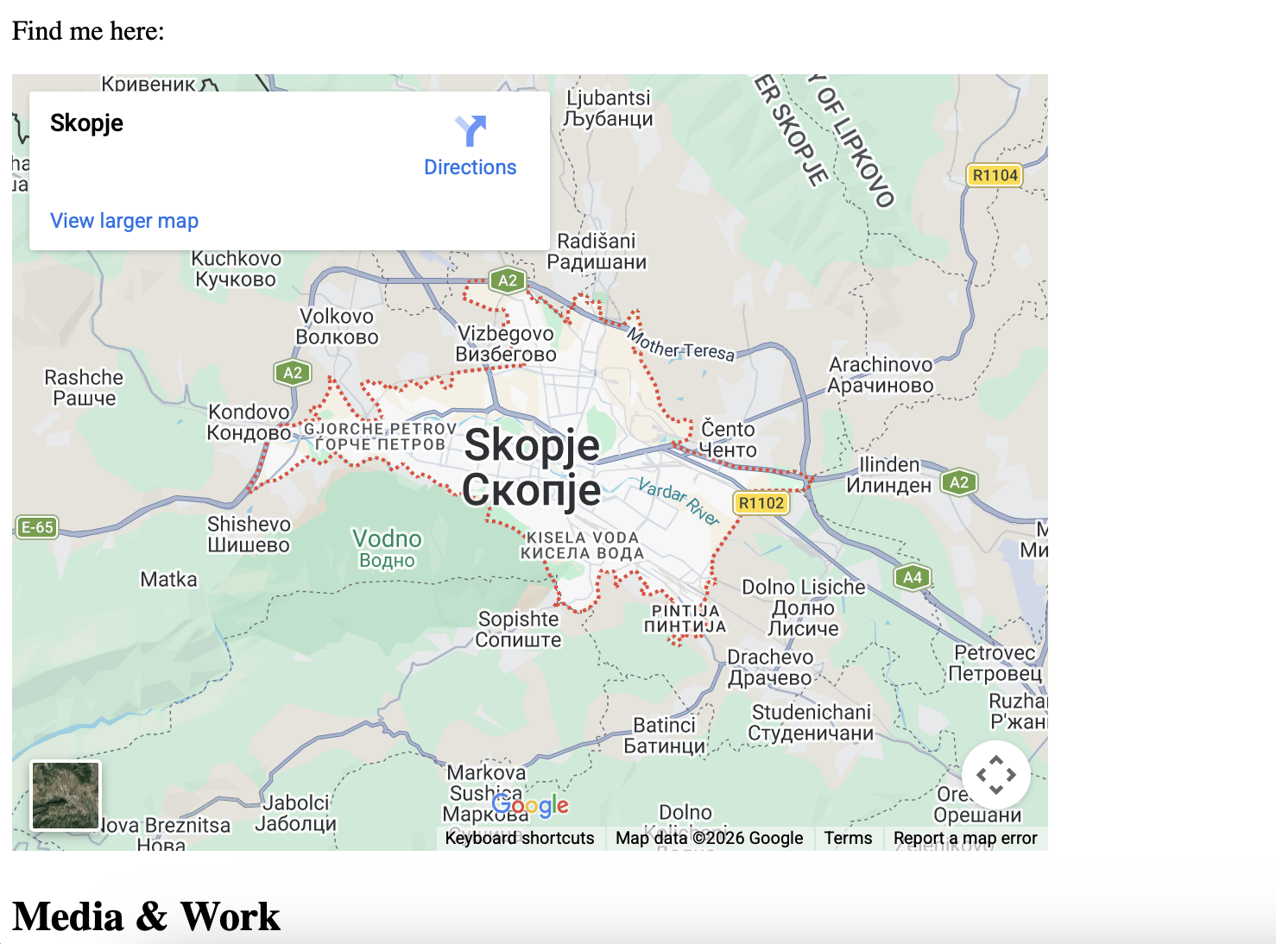
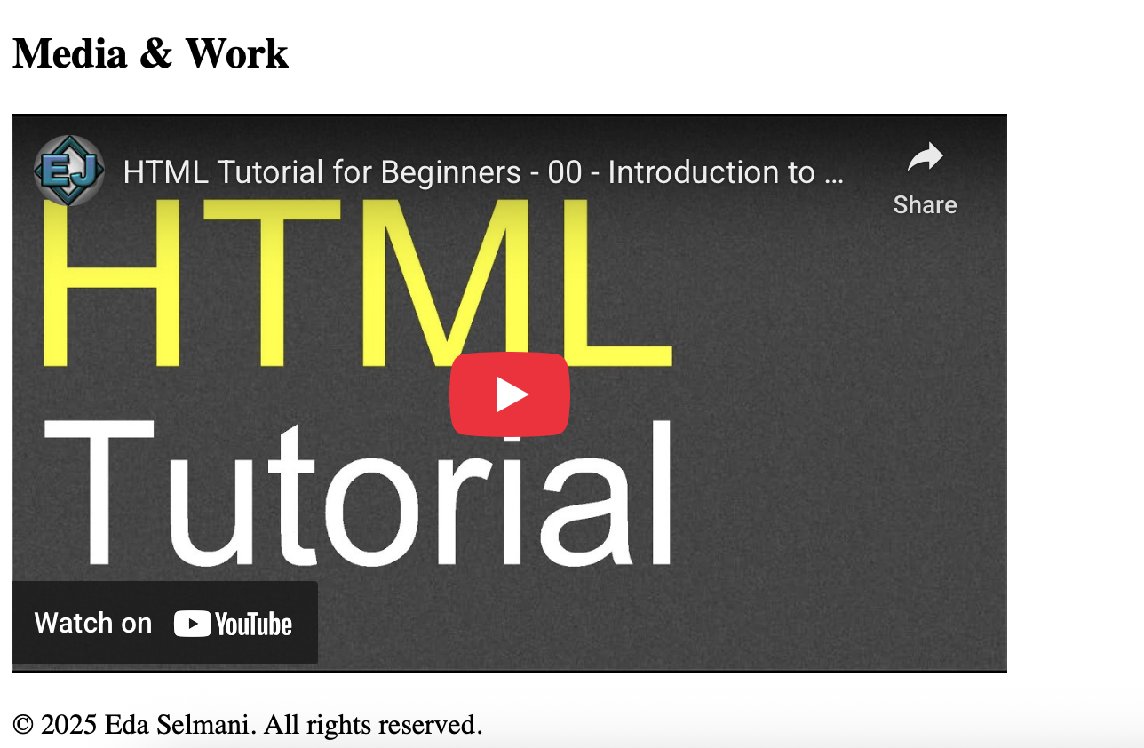

Exercise 3: Accessibility audit of your portfolio
Go through your index.html and make these improvements: (1) Add aria-label to any icon-only buttons or links (e.g., <a href='mailto:...' aria-label='Send me an email'>📧</a>). (2) Confirm every <img> has a meaningful alt text (not just 'image'). (3) Add lang='en' to your <html> tag if it's not there. (4) Add a skip navigation link at the very top of the <body>: <a href='#main'>Skip to main content</a>. (5) Add id='main' to your <main> element. (6) Check all your form inputs have associated <label> tags with matching for/id attributes. Save and test by pressing Tab — can you navigate through the whole page with just your keyboard?
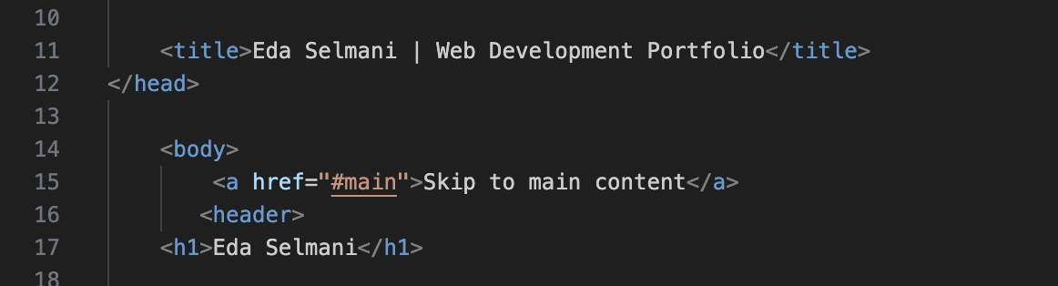

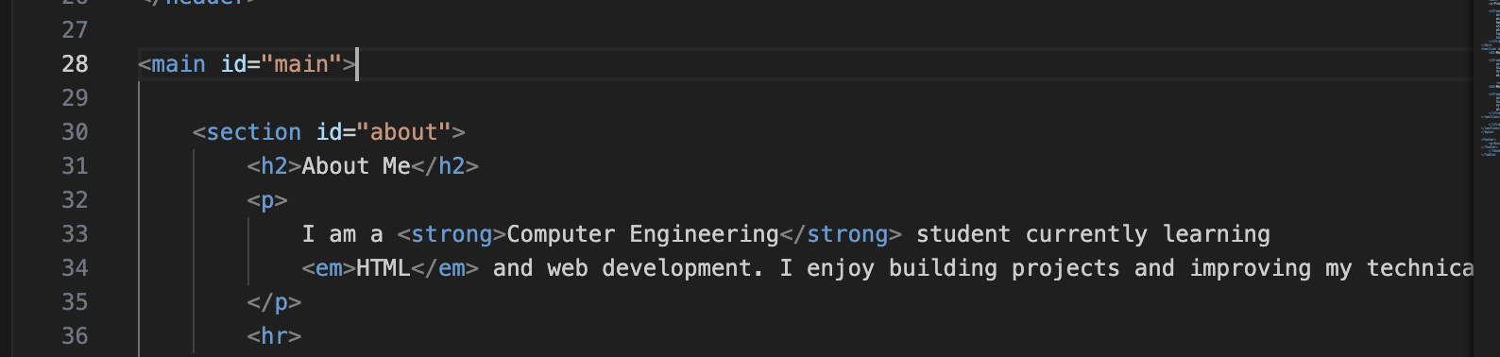

Exercise 4: Enhance your portfolio with advanced elements
Add these finishing touches to your portfolio: (1) Wrap your profile image in a <figure> element and add a <figcaption> describing the photo. (2) Add a <details> / <summary> element somewhere — for example, expand your About Me section with 'Read more about me...'. (3) Add HTML skill proficiency bars to your Skills section using <progress> elements (e.g., HTML: 80%, CSS: coming soon). (4) Add a <blockquote> in your About section with an inspiring quote that motivates you. (5) In your form, change the skills dropdown to use a <datalist> input instead of <select> — compare the experience!
FULL WEB FINAL LOOK POLISHED

